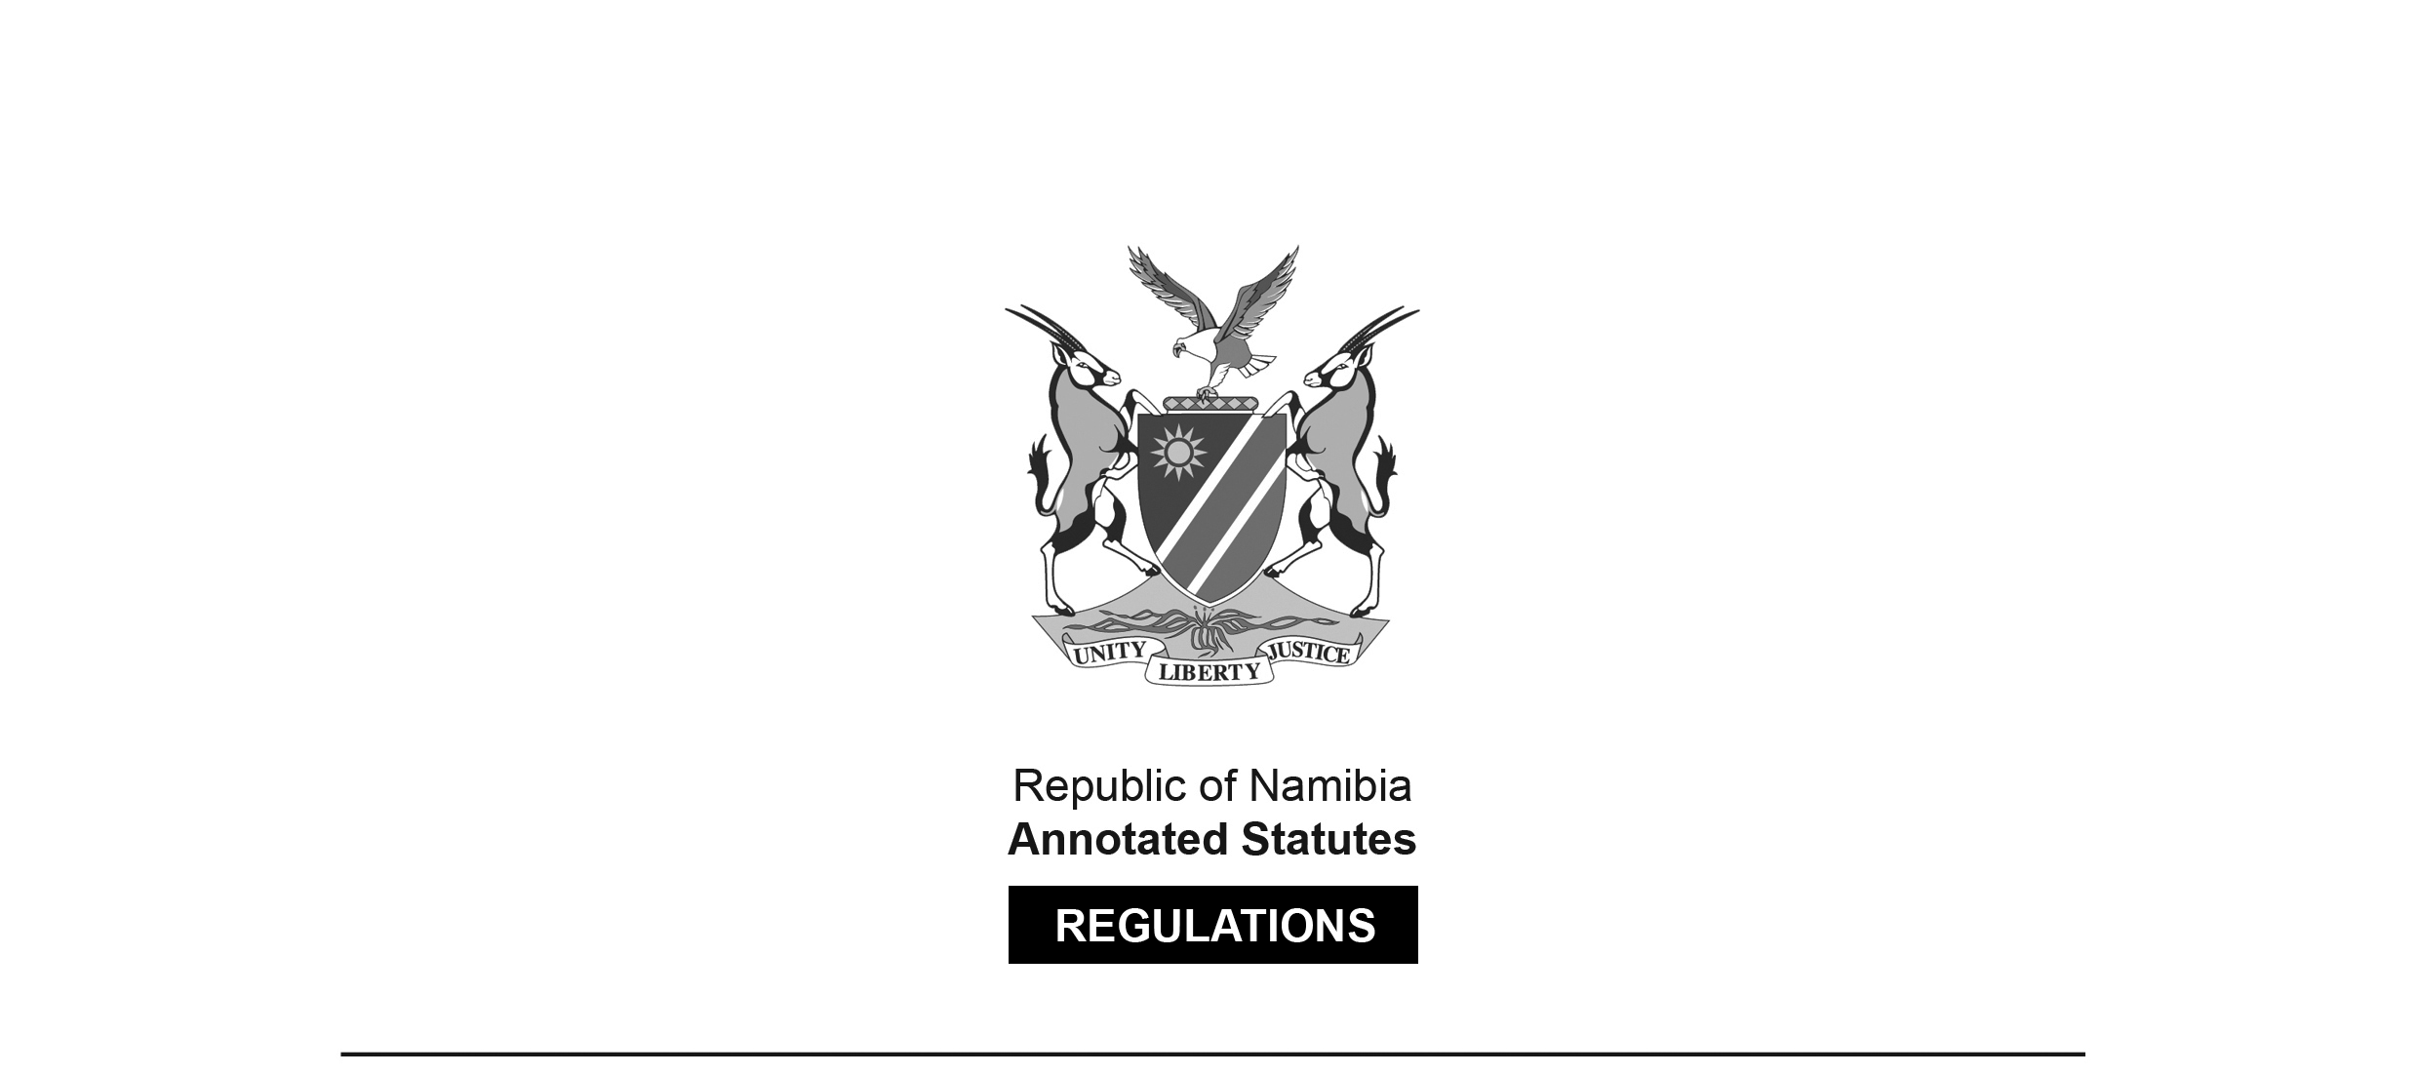

REGULATIONS SURVIVING IN TERMS OF

Health Professions Act 16 of 2024

section 95(10)

Regulations relating to the Minimum Requirements of Study for Registration as a Speech Therapist, an Audiologist, or a Speech Therapist and Audiologist

Government Notice 143 of 2011

([GG 4768](http://www.lac.org.na/laws/2011/4768.pdf))

came into force on date of publication: 5 August 2011

These regulations were made in terms of section 55 read with section 19(1) of the Allied Health Professions Act 7 of 2004, which was repealed by the Health Professions Act   
16 of 2024. Pursuant to section 95(10) of the Health Professions Act 16 of 2024,   
they are deemed to have been made under that Act.

The Government Notice which publishes these regulations notes that they were made   
on the recommendation of the Allied Health Professions Council of Namibia. It repeals the regulations contained in RSA GN R.2333/1976 ([RSA GG 5349](http://www.lac.org.na/laws/GGsa/rsagg5349.pdf)). These previous regulations were made in terms of the RSA Medical, Dental and Supplementary Health Service Professions   
Act 56 of 1974. They survived in terms of section 50(2) of the Allied Health Services Professions Act 20 of 1993 and section 62(2) of its successor, the Allied Health Professions Act 7 of 2004.

ARRANGEMENT OF REGULATIONS

1. Definitions

2. Minimum qualifications required for registration as a speech therapist

3. Minimum qualifications required for registration as an audiologist

4. Minimum qualifications required for registration as a speech therapist and audiologist

5. Recognition of qualification by Council

**Definitions**

**1.** In these regulations, unless the context otherwise indicates, a word or expression defined in the Act has that meaning, and -

“the Act” means the Allied Health Professions Act, 2004 (Act No. 7 of 2004).

**[****The Allied Health Professions Act 7 of 2004 has been   
replaced by the Health Professions Act 16 of 2024.]**

**Minimum qualifications required for registration as a speech therapist**

**2.** (1) Subject to compliance with the other requirements prescribed by or under the Act, a person may be registered as a speech therapist, if that person is the holder of any of the following qualifications:

**Educational Institution Qualification**

**SOUTH AFRICA**

University of Cape Town Bachelor of Science

(Speech Language Pathology)

Bachelor of Science Speech

(Conversion)

University of KwaZulu-Natal Bachelor of Communication

(formerly University of Pathology (Speech Language

Durban-Westville) Pathology)

University of Pretoria Bachelor of Communication

Pathology (Speech Language

Pathology)

University of Stellenbosch Bachelor of Speech Language

and Hearing

**THE NETHERLANDS**

Hogeskole Suid, Haarlem Bachelor in Speech Therapy

**GERMANY**

Philips University, Marsburg National Examination for

Speech Therapists

Euro Medizinale College, Trier National Examination for

Speech Therapists

Schule für Logopedie, Karisruhe National Examination for

Speech Therapists

(2) Any person who is not the holder of a qualification prescribed by subregulation (1) may be registered as a speech therapist, subject to subregulation (3) of this regulation, to regulation 5 and to compliance with the other requirements prescribed by or under the Act, if he or she is the holder of a Bachelors Degree in Speech and Language Pathology, obtained at an educational institution approved by the Council after the full time study for a period of not less than four years at that educational institution.

(3) The education, tuition and training prescribed by subregulation (2) must include -

(a) education, tuition and training in the subjects of -

(i) The Introduction to Audiology;

(ii) Identification Audiometry;

(iii) Pathology of Developmental or Acquired Speech Disorders;

(iv) Pathology of Developmental or Acquired Disorders of Language and Language Processing;

(v) Pathology of Developmental or Acquired Disorders of Oral, Pharyngeal, Oesophageal and related functions;

(vi) Psychology;

(vii) Phonetics and Linguistics; and

(viii) (aa) Anatomy;

(bb) Physiology;

(cc) Neurology; and

(dd) Neuropathology,

of Speech, Language and Hearing;

(b) a research project in the field of Speech and Language Pathology or Audiology; and

(c) practical training at the educational institution during the period of full time study in the subjects of -

(aa) Audiology 50 hours; and

(bb) Speech Pathology 250 hours.

**Minimum qualifications required for registration as an audiologist**

**3.** (1) Subject to compliance with the other requirements prescribed by or under the Act, a person may be registered as an audiologist, if that person is the holder of any of the following qualifications:

**Educational Institution Qualification**

**SOUTH AFRICA**

University of Cape Town Bachelor of Science (Audiology)

University of KwaZulu- Natal, Bachelor of Communication

(formerly University of Pathology (Audiology)

Durban-Westville)

University of Pretoria B Communication Pathology

(Audiology)

(2) Any person who is not the holder of a qualification prescribed by subregulation (1) may be registered as an audiologist, subject to subregulation (3) of this regulation, to regulation 5 and to compliance with the other requirements prescribed by or under the Act, if he or she is the holder of a Bachelors Degree in Audiology, obtained at an educational institution approved by the Council after the full time study for a period of not less than four years at that educational institution.

(3) The education, tuition and training prescribed by subregulation (2) must include -

(a) education, tuition and training in the subjects of -

(i) Clinical Audiology;

(ii) Paediatric Audiology;

(iii) Occupational Audiology;

(iv) Vestibular Audiology;

(v) Aural Rehabilitation;

(vi) Pathology of Developmental or Acquired Disorders of Language and Language Processing and Speech caused by Hearing Loss;

(vii) Psychology;

(viii) Phonetics and Linguistics; and

(ix) (aa) Anatomy;

(bb) Physiology;

(cc) Neurology; and

(dd) Neuropathology,

of Speech, Language and Hearing;

(b) a research project in the field of Audiology; and

(c) practical training at the educational institution during the period of full time study in the subjects of -

(i) Audiology 250 hours

(ii) Speech Pathology 50 hours.

**Minimum qualifications required for registration as a speech therapist and audiologist**

**4.** (1) Subject to compliance with the other requirements prescribed by or under the Act, a person may be registered as a speech therapist and audiologist, if that person is the holder of the following qualification:

**Educational Institution Qualification**

**SOUTH AFRICA**

University of Pretoria B Communication Pathology

(Speech and Language Pathology,

and Audiology)

Bachelors Degree in Logopaedics

University of the Witwatersrand Bachelor of Science (Speech Therapy

and Audiology)

University of Cape Town Bachelor of Science (Speech Therapy

and Audiology)

(2) Any person who is not the holder of the qualification prescribed by subregulation (1) may be registered as a speech therapist and audiologist, subject to subregulation (3) of this regulation, to regulation 5 and to compliance with the other requirements prescribed by or under the Act, if he or she is the holder of a Bachelors Degree in Speech and Language Pathology and Audiology, obtained at an educational institution approved by the Council after the full time study for a period of not less than four years at that educational institution, which study for that Degree or Diploma must include -

(a) education, tuition and training in the subjects of -

(i) Clinical Audiology;

(ii) Paediatric Audiology;

(iii) Occupational Audiology;

(iv) Aural Rehabilitation;

(v) Pathology of Developmental or Acquired Speech Disorders;

(vi) Pathology of Developmental or Acquired Disorders of Language and Language Processing;

(vii) Pathology of Developmental or Acquired Disorders of Oral, Pharyngeal, Oesophageal and related functions;

(viii) Psychology;

(ix) Phonetics and Linguistics; and

(x) (aa) Anatomy;

(bb) Physiology;

(cc) Neurology; and

(dd) Neuropathology,

of Speech, Language and Hearing; and

(b) a research project in the field of Speech and Language Pathology or Audiology; and

(c) practical training at the educational institution during the period of full time study in the subjects of -

(i) Audiology 200 hours

(ii) Speech Pathology 200 hours.

**Recognition of qualification by Council**

**5.** The Council may recognise, for the purpose of the registration of a person as -

(a) a speech therapist, a qualification prescribed by subregulation (2) of regulation 2;

(b) an audiologist, a qualification prescribed by subregulation (2) of regulation 3; or

(c) a speech therapist and audiologist, a qualification prescribed by subregulation (2) of regulation 4,

if -

(i) the educational institution at which that person obtained that qualification is approved by the Council for that purpose;

(ii) the registration authority responsible for the registration of a person to practise as a speech therapist, an audiologist or a speech therapist and audiologist, as the case may be, in the country in which that person obtained that qualification, recognises that qualification for registration to practise as a speech therapist, an audiologist or a speech therapist and audiologist, as the case may be, in that country; and

(iii) that person complies with the other requirements for registration as a speech therapist, an audiologist or a speech therapist and audiologist, as the case may be, prescribed by or under the Act.